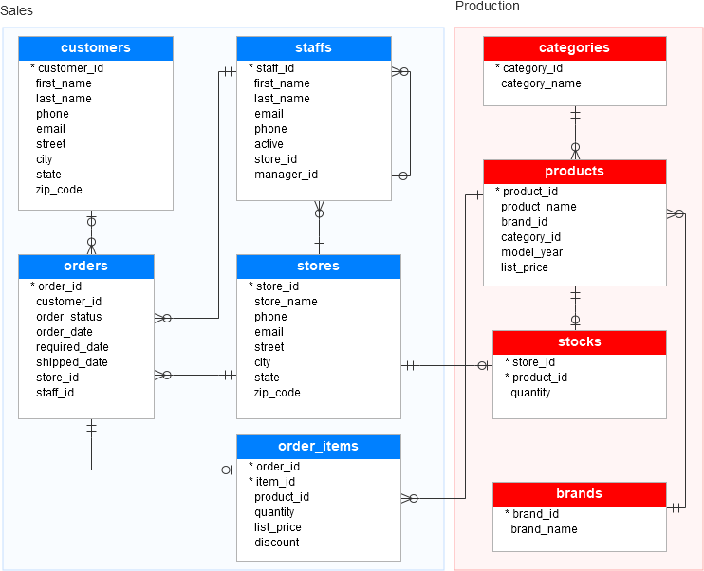

As you can see from the diagram, the BikeStores sample database has two schemas sales and production, and these schemas have nine tables.